

**Batch: B-1 Roll No.: 16010422234 Experiment No.: 01**

**__________________________________________________________________________**

**Aim:** Mini Project on object oriented software engineering for a business application.

**__________________________________________________________________________**

**Resources needed:** Computer with VR-capable hardware, VR development software (Unity), Textual description and dataset of numerical data, Software tools: Python(for backend), Unity or other VR frameworks, IDE for development (Visual Studio), Data storage and processing tools (Database), VR headset for testing and implementation.

**__________________________________________________________________________**

**Activities:**

**Students are required to choose one business application and prepare the following for the same.**

1. Problem Definition
2. Project Scope
3. Choice of Process Model
4. Roles and Responsibilities
5. GUI based Implementation of one Module (one use case)

**__________________________________________________________________________**

**Results:**

**Problem Definition:**

The project focuses on generating VR visualizations from textual descriptions of numerical data. This will help users interact with complex data in a 3D immersive environment, enhancing data analysis, decision-making, and business intelligence. The process includes converting textual data descriptions into visual 3D representations for easy user interaction.

**Project Scope:**

The project involves developing a system where textual descriptions of numerical data (such as sales figures or performance metrics) are transformed into interactive VR visualizations. The scope includes:

* Parsing and analyzing textual data inputs.
* Generating 3D visualizations from this data.
* Providing an interactive user interface within a VR environment.

**Choice of Process Model:**

The Agile Model will be adopted for this project due to its flexibility and iterative approach, enabling continuous development and refinement based on feedback. The iterative nature of Agile makes it well-suited for VR-based applications where frequent testing and adjustments are needed.

**Roles and Responsibilities:**

* **Project Manager:** Oversees the project, ensuring the timely completion of tasks, and manages communication among team members.
* **Data Analyst:** Analyzes textual descriptions of numerical data to ensure accurate input to the system.
* **Software Developer:** Develops the backend and integrates the textual data processing with the VR visualization engine.
* **UI/UX Designer:** Designs the user interface for the VR environment and ensures a seamless user experience.
* **Tester:** Tests the system for performance, accuracy of visualizations, and user interaction functionality.

**GUI-based Implementation of One Module (One Use Case):**

A module will be developed where the user inputs textual descriptions of numerical data. The system will parse the data and generate corresponding 3D visualizations in the VR environment. The user can interact with the visualized data by rotating, zooming, or selecting data points for further analysis.

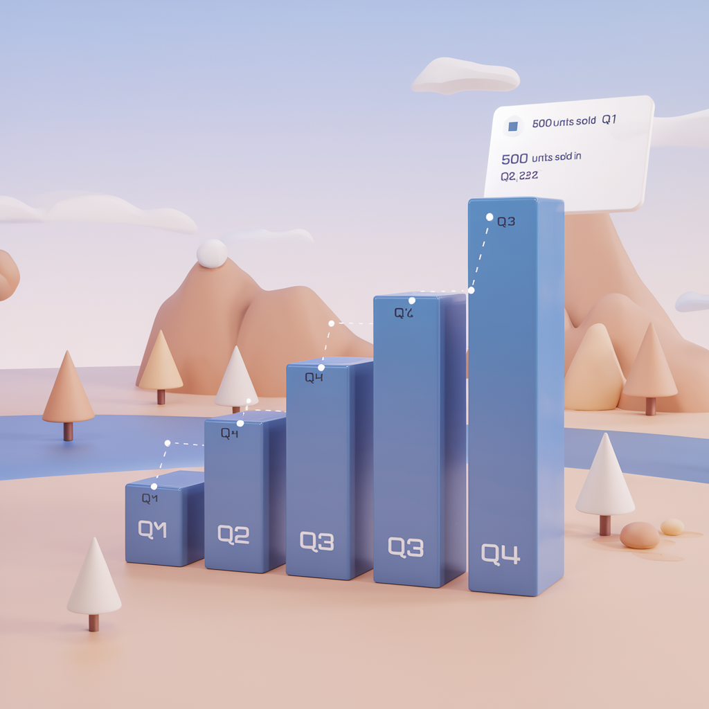

**__________________________________________________________________________**

**Outcomes: CO1 – Comprehend process models**

**__________________________________________________________________________**

**Conclusion: (Conclusion to be based on the outcomes achieved)**

The project successfully demonstrates the ability to generate VR visualizations from textual descriptions of numerical data. Through the use of object-oriented software engineering principles, the project integrates VR technology to enhance data interpretation and user experience. The outcomes achieved validate the feasibility of using immersive environments for complex data visualization and business applications.

**__________________________________________________________________________**

**Grade: AA / AB / BB / BC / CC / CD / DD**

**Signature of faculty in-charge with date**

**__________________________________________________________________________**

**References:**

**Books/ Journals/ Websites:**

1. Roger S. Pressman, Software Engineering: A practitioners Approach, 7th Edition, McGraw Hill, 2010
2. <https://www.sharelatex.com/>

**__________________________________________________________________________**